Project Design Phase-II
Data Flow Diagram & User Stories
Date | 31 January 2025
Team ID | SWTID-2026-3138
Project Name | ComicCraft - AI Comic Story Creator using Gemini Models
Maximum Marks | 4 Marks
Data Flow Diagrams:
A Data Flow Diagram (DFD) is a traditional visual representation of the information flows within a system. A neat and clear DFD can depict the right amount of the system requirement graphically. It shows how data enters and leaves the system, what changes the information, and where data is stored.
ComicCraft DFD (Level 0):
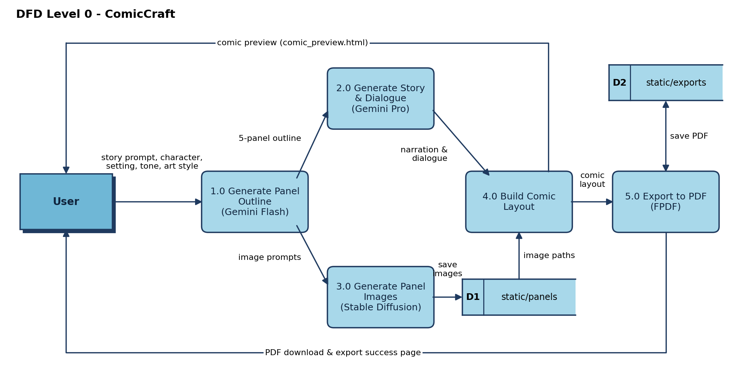
Flow:
- User enters the story prompt, main character name, setting, tone, and art style on the web form (index.html), which is submitted to the FastAPI /generate route.
- Gemini Flash generates a structured 5-panel outline (panel number, title, scene description, image prompt).
- Gemini Pro expands the outline into narration and character dialogue for every panel.
- Stable Diffusion generates a comic-style illustration for each panel from its image prompt and saves it to static/panels.
- layout_builder.py matches each image with its panel story and returns the comic layout, which is shown to the user on the comic preview page.
- When the user downloads the comic, exporters.py compiles the layout into a PDF with FPDF, saves it to static/exports, and the user lands on the export success page.
User Stories
User stories for the ComicCraft product, grouped by user type and functional requirement (epic).
User Type | Functional Requirement (Epic) | User Story Number | User Story / Task | Acceptance criteria | Priority | Release
Comic Creator (Web user) | Story Input | USN-1 | As a user, I can enter a story prompt, main character name, setting, tone, and art style on the home page. | The form submits all five fields to the /generate route. | High | Sprint-1
Comic Creator (Web user) | Story Input | USN-2 | As a user, I can choose the tone (e.g., dramatic, funny) and art style (e.g., anime, comic book) for my comic. | The selected tone and style are reflected in the generated story and illustrations. | Medium | Sprint-1
Comic Creator (Web user) | Comic Generation | USN-3 | As a user, I receive a structured 5-panel outline generated from my story prompt. | Each panel has a number, title, scene description, and image prompt. | High | Sprint-1
Comic Creator (Web user) | Comic Generation | USN-4 | As a user, I receive narration and character dialogue for every panel. | Story text matches the outline and the chosen tone. | High | Sprint-1
Comic Creator (Web user) | Comic Generation | USN-5 | As a user, I receive a comic-style illustration for every panel. | One image per panel is generated and saved in static/panels. | High | Sprint-2
Comic Creator (Web user) | Comic Preview | USN-6 | As a user, I can view my generated comic panel by panel on a preview page. | Title, image, scene description, and narration are shown for each panel in order. | High | Sprint-2
Comic Creator (Web user) | Comic Preview | USN-7 | As a user, I can change the tone or art style and regenerate my comic. | Submitting new inputs regenerates the outline, story, and images. | Medium | Sprint-2
Comic Creator (Web user) | Export | USN-8 | As a user, I can download my comic as a PDF. | A PDF with images and narration on consecutive pages is saved with a timestamped filename in static/exports. | High | Sprint-2
Comic Creator (Web user) | Export | USN-9 | As a user, I see a confirmation page after exporting my comic. | I am redirected to /export-success and can start a new comic. | Low | Sprint-3
Comic Creator (Web user) | Error Handling | USN-12 | As a user, I see a clear error message if comic generation fails (e.g., an API error). | Failures are handled gracefully and the app does not crash. | Medium | Sprint-3
API Client / Developer | API Access | USN-10 | As an API client, I can send a JSON request to /generate-comic/json to generate a comic. | A valid request returns the comic layout data and PDF path as JSON; an invalid request returns an error. | Medium | Sprint-3
API Client / Developer | API Access | USN-11 | As a developer, I can test image generation separately using /test-image. | A custom prompt returns a generated image without running the full comic pipeline. | Low | Sprint-3

